UNIVERSITY OF WAH (UOW)

DEPARTMENT OF COMPUTER SCIENCE



BSCS 3RD B

REG #: UW-24-CS-BS-088

SUBMITTED BY: SAADI SAFDAR

SUBMITTED TO: Ms. MUNIBA KHAN

COURSE TITLE: DATA STRUCTURES

COURSE CODE: CS – 201 L

FINAL LAB SESSIONAL

- Linear Queue (Array-based)
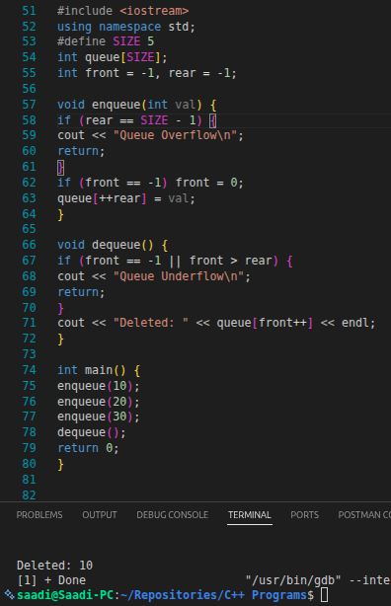

- Priority Queue

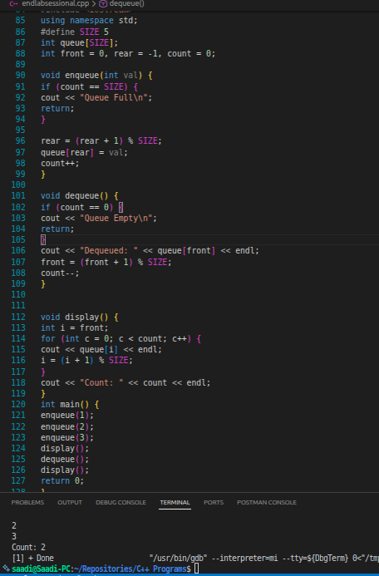

- Heap & Find max

